# Assignment 2 report

Tianyu Zhang Z5135099

Peter Hehir Z8372276

## 1. Data analysis

We combined data for day 1 and day 2 as a combined dataset, then tested the performance of each sensor in this dataset.

### 1.1 Motion sensor

In Table 1 shows the accuracy of each motion sensors, most of them are too unreliable to be based on to make direct decisions.

|  |  |  |  |  |  |  |  |  |  |  |
| --- | --- | --- | --- | --- | --- | --- | --- | --- | --- | --- |
|  | Motion  sensor 1 | Motion  sensor 2 | Motion  sensor 3 | Motion  sensor 4 | Motion  sensor 5 | Motion  sensor 6 | Motion  sensor 7 | Motion  sensor 8 | Motion  sensor 9 | Motion  sensor 10 |
| True motion | 0 | 0 | 0 | 0.919 | 0.503 | 0 | 0 | 0.769 | 0 | 0 |
| True non motion | 0.395 | 0.157 | 0.267 | 0.573 | 0.823 | 0.321 | 0.081 | 0.806 | 0.113 | 0.091 |
| False motion | 1 | 1 | 1 | 0.081 | 0.497 | 1 | 1 | 0.231 | 1 | 1 |
| False non motion | 0.605 | 0.843 | 0.733 | 0.427 | 0.177 | 0.678 | 0.918 | 0.194 | 0.887 | 0.909 |

Table 1 Motion sensors performance.

### 1.2 Cameras

We tested performance of cameras in 4 aspects, motion detecting, people counting, difference detection and trend detection. As a result, cameras have the best performance in trend detection.

Table 2 shows the accuracy of cameras in motion detection, “True motion” means there are people in a room when the camera show a positive number. “True non motion” means the room is empty when the camera show 0. As a result, cameras have good accuracy when they show 0.

|  |  |  |  |  |
| --- | --- | --- | --- | --- |
|  | Camera 1 | Camera 2 | Camera 3 | Camera 4 |
| True motion | 0.608 | 0.564 | 0.277 | 0.838 |
| True non motion | 1 | 1 | 1 | 0.951 |
| False motion | 0.392 | 0.436 | 0.723 | 0.162 |
| False non motion | 0 | 0 | 0 | 0.049 |

Table 2: Camera performance in motion detection.

Table 3 shows the accuracy of cameras in counting exact number of people in the room (True count), detecting the exact changing of the people number in the room (True difference), and detecting the increasing / decreasing / unchanged trend of people number in the room.

|  |  |  |  |  |
| --- | --- | --- | --- | --- |
|  | Camera 1 | Camera 2 | Camera 3 | Camera 4 |
| True count | 0.109 | 0.123 | 0.064 | 0.383 |
| True difference | 0.775 | 0.762 | 0.809 | 0.419 |
| True trend | 0.814 | 0.782 | 0.833 | 0.692 |

Table 3: Camera performance in people counting, difference detection and trend detection.

### 1.3 Robot

Table 4 shows the performance of robots in people counting and motion detection, they both have 100% accuracy, which means robot readings should have the highest priority and can be used to support direct decisions making.

|  |  |  |
| --- | --- | --- |
|  | Robot 1 | Robot 2 |
| True count | 1 | 1 |
| True motion | 1 | 1 |

Table 4: Robot performance in people counting and motion detection.

### 1.4 door sensor

## 2. Models

### 2.1 Model considering multiple rooms

We tested building combined model for several rooms, to prevent the model become too complex, we built 5 separate models the building. As shown in Figure 1, model 1 was for room 1, 2, 7, 8 and corridor 3 (blue), model 2 for room 4, 5 and 6 (orange) model 3 for room 3 (pink), model 4 for room 9 (green) and model 5 for room 10 (yellow).

Figure 1: Multiple rooms combined models for the building.

Joined tree was selected as the probability graph algorithm for these models. We first integrated readings of door sensors, motion sensors and cameras into Bayesian networks, then converted them into join trees. Table 5 shows outcome space chosen of each type of variables according to the data analysis result.

Door sensors have 3 possible values: "odd", "even" and "zero". If the value is "odd", then the states of rooms it connects are likely change, if the value is "zero", then the states are likely to keep unchanged. For cameras, according to the analysis results in Table 2 and 3, they have the best performance when detecting the changing trend in the room, they are also reliable when they determine the room is empty. Therefore, cameras have 4 outcome space: "increasing", "decreasing", "unchanged" and "zero".

|  |  |
| --- | --- |
| Variables | Outcome space |
| Door sensor | “odd”, "even", "zero" |
| Motion sensor | 'motion', 'no motion' |
| Camera | 'increasing', "decreasing", "unchanged", "zero" |
| Room & Corridor | '0', '1', ">1" |

Table 5: Outcome space for variables

In the Bayesian model, we assumed the reading of the door sensor at time t (Dt) will be affected by the state of the room it connects at time t – 1 (Rt-1), and Dt can affect the state of this room at time t (Rt). Cameras measures the change in rooms, therefore the reading of cameras at time t (Camt) can be affected by the current and past state of the room it is in (Rt-1 and Rt). The reading of motion sensor at time t (Mt) is affected by the state of the room it is in at time t (Rt). Figure 2 shows the Bayesian network and join tree for room 4, 5 and 6. Since door 4 connects room 4 and 5, so D4t is affected by R4t-1 and R5t-1, and it affect R4t and R5t. Camera 2 is in room 4, so Cam2t is affected by R4t-1 andR4t. Motion sensor 4 is in room 4, so M4t is affected by R4t.

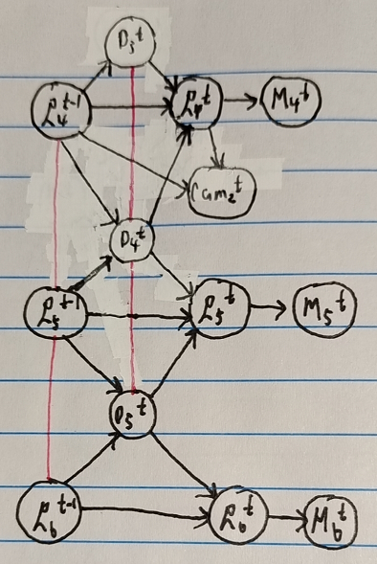

Figure 2: Bayesian network (left) and join tree (right) for room 4, 5, 6 model.

the red lines are edges added during moralization.

Readings of sensors that were not None and states of each room at time t-1 were used as evidence e. For each room r P(r, e) was calculated using the join tree. The light of room r will be turn off if P(r = ‘0’, e) > 4 * (P(r = ‘1’, e) + P(r = ‘>1’, e)). Before determining the action for room r, we also check the robot reading. If there is a robot in room r, then the action will be made solely depend on robot reading since they have 100% accuracy.

Figure 3 and 4 show Bayesian networks and join trees for room 1, 2, 3, 7, 8, 9, 10, which follow same assumptions mentioned above.

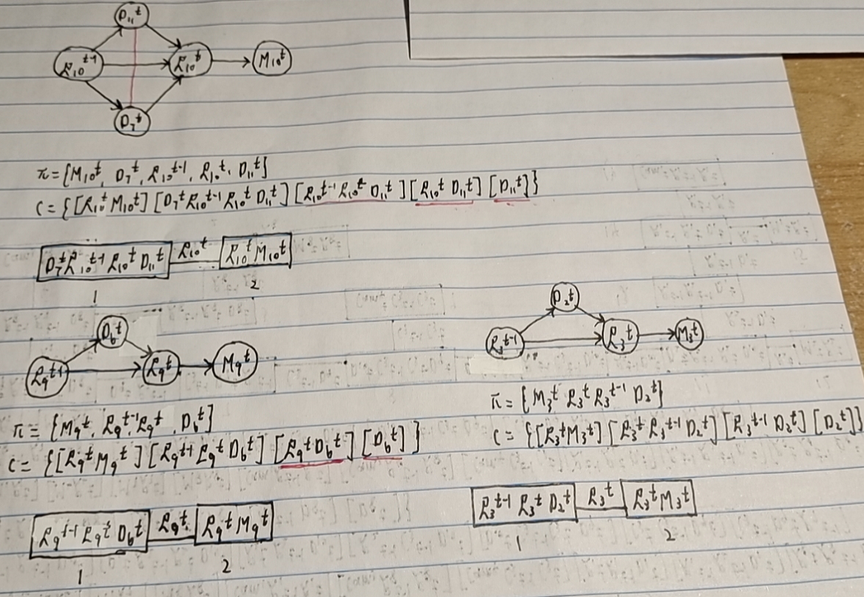

Figure 3: Models for room 10 (top left), 9 (bottom left) and 3 (bottom right).

Figure 4: Model for room 1, 2, 7, 8.

The largest tree width is 3 in these join tree models. When answering a query, the complexity will be max(O(M), O(V)), where M is the maximum number of income message a cluster has, V is the largest number of variables in a cluster that have to be marginalized out. As a result, the model had 217794 cents cost in 10 days with 260.57 seconds runtime. It had acceptable runtime and lower cost than keeping the light on all the time.

### 2.1 Universal one room model for all rooms